**Experiment No:7**

**Practice Queries using ANY, ALL, IN, EXISTS, UNION, INTERSECT Set Operators**

* SELECT ProductName FROM Products WHERE ProductID = ANY ( SELECT ProductID FROM OrderDetails WHERE Quantity = 10);

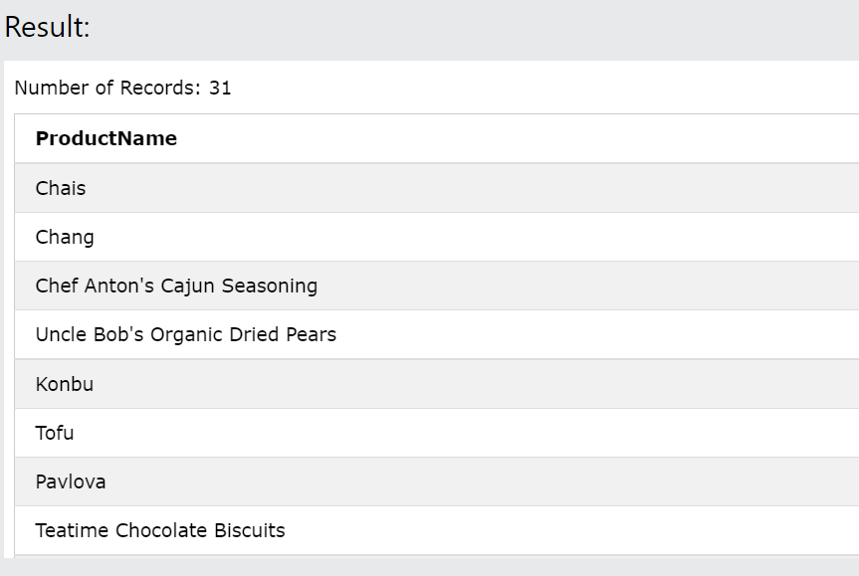

* SELECT ALL ProductName FROM Products WHERE TRUE;

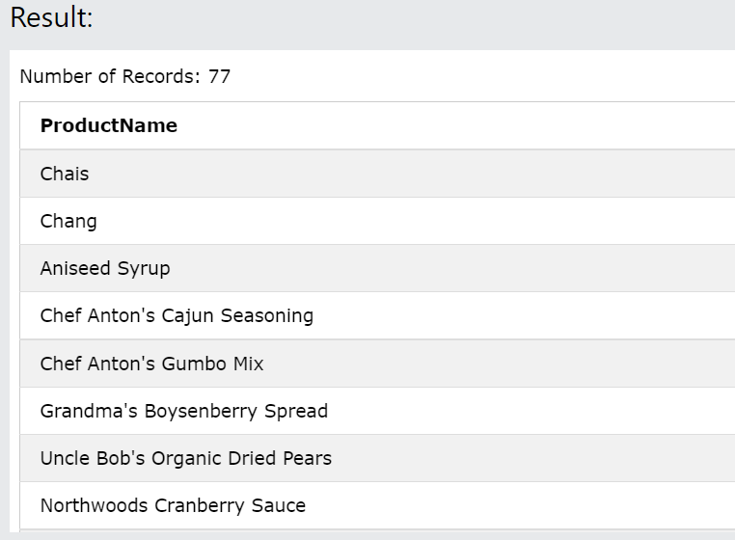

* SELECT ProductName FROM Products WHERE ProductID = ALL (SELECT ProductID FROM OrderDetails WHERE Quantity = 10);

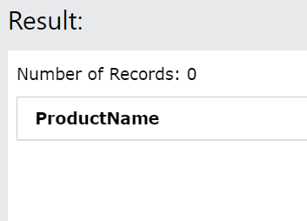

* SELECT * FROM Customers WHERE Country IN ('Germany', 'France', 'UK');

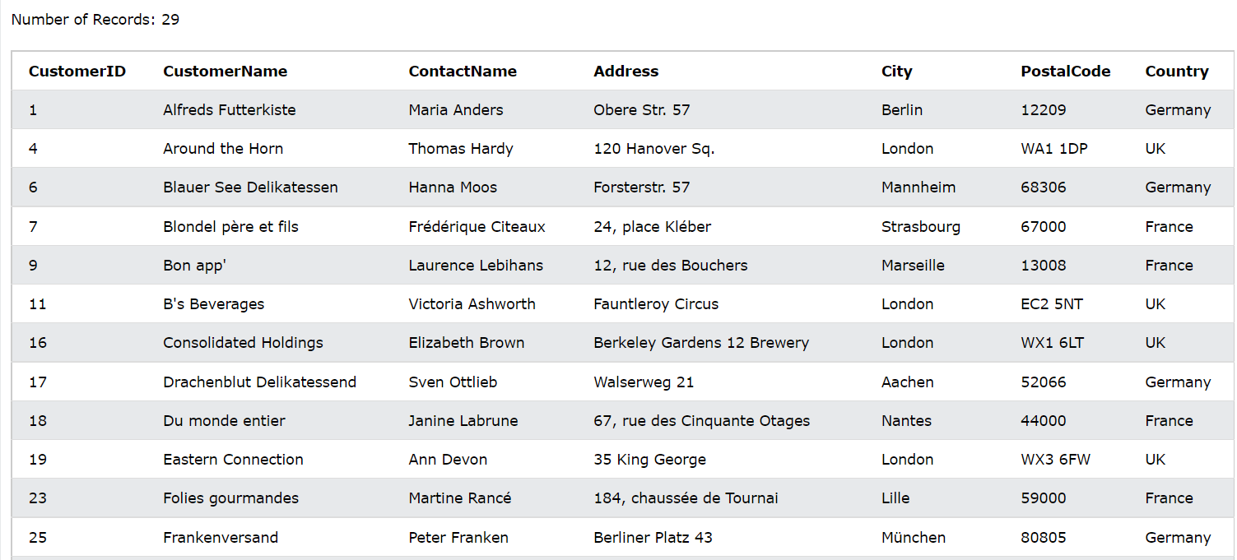

* SELECT * FROM Customers WHERE Country NOT IN ('Germany', 'France', 'UK');

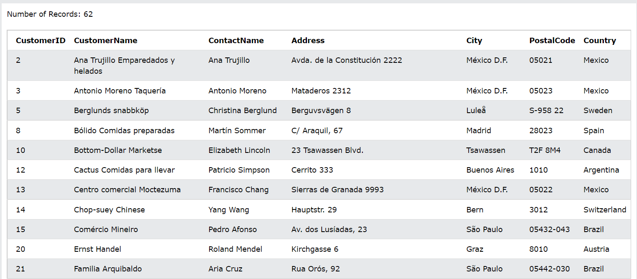

* SELECT * FROM Customers WHERE Country IN (SELECT Country FROM Suppliers);

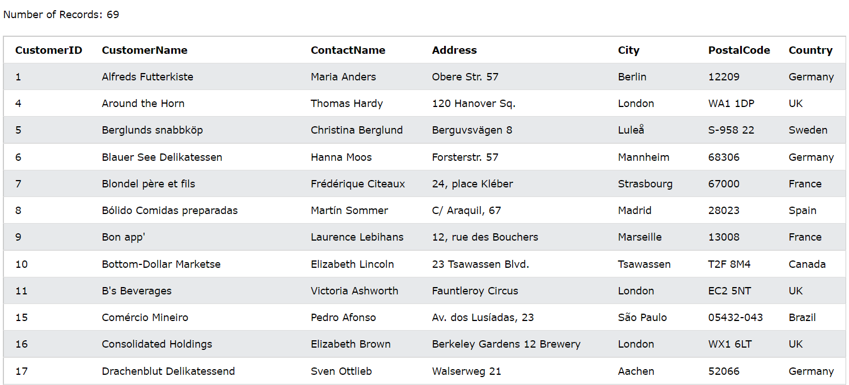

* SELECT SupplierName FROM Suppliers WHERE EXISTS (SELECT ProductName FROM Products WHERE Products.SupplierID = Suppliers.supplierID AND Price < 20);

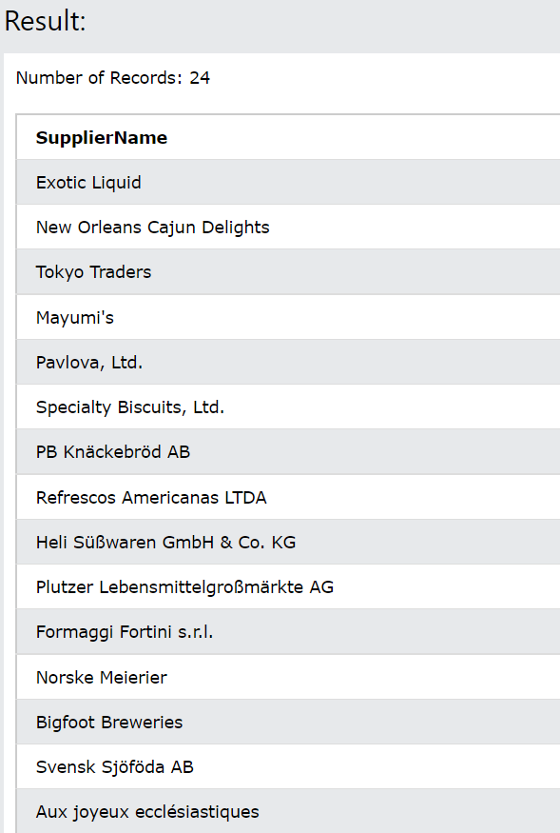

* SELECT 'Customer' AS Type, ContactName, City, Country FROM Customers UNION SELECT 'Supplier', ContactName, City, Country FROM Suppliers;

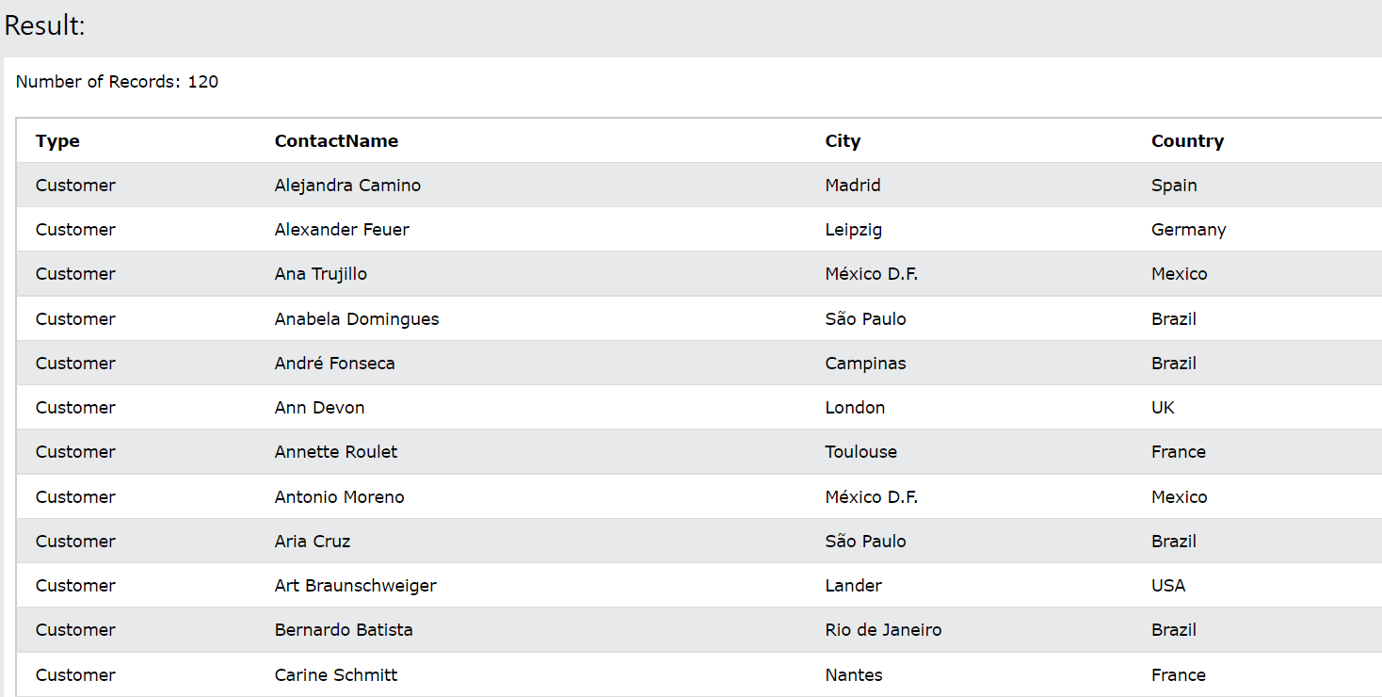

* SELECT supplier_id FROM suppliers INTERSECT SELECT supplier_id FROM orders;